IEEE SB, MARIAN ENGINEERING COLLEGE
MEMBERSHIP DEVELOPMENT SESSION AND PHOTOSHOP WORKSHOP, FEBRUARY 11,2017
REPORT
The membership development session cum Photoshop workshop was conducted at Marian engineering college on 11th of February, 2017. 220 students belonging to 6 different colleges in the IEEE Travancore hub participated in the event. To cater to the needs of these students, some 30 students from different branches in the college took part as volunteers. From Marian engineering college, there were 165 participants, John Cox college,53 students then remaining students from Bethlehem institute of technology, College of engineering Attingal, College of engineering Adoor, College of engineering Aranmula, LBSIT Trivandrum, TKMIT Kollam, Mangalam college of engineering and SHM Institute of Technology. The programme commenced at 10 am and ended by 5 pm in the evening.
The morning session was handled by Ms. Pooja Manju, final year student of college of engineering, Trivandrum. She introduced the organization IEEE to the new students and gave a detailed presentation of the working of the IEEE. This session was followed by a preliminary Photoshop session arranged by Ms. Megha Ben from CET. She along with 2 other students handled a preliminary design art awareness session for the students. She highlighted the job opportunities and the demand in today's world for designers. After the lunch break, the students were divided into different groups and hands on Photoshop workshop was taken. One section was handled by Ms. Megha Ben and the other section was handled by Mr. Nanda Kishore from Marian Engineering College, Mechanical department. The workshop was spread out between one drawing hall in the Administrative Block and 3 computer labs in the Administrative Block, mechanical dept lab and the OS lab in the CS dept.
The overall response to the programme was very positive. Many students expressed their wish to become members and also take up volunteering with IEEE.
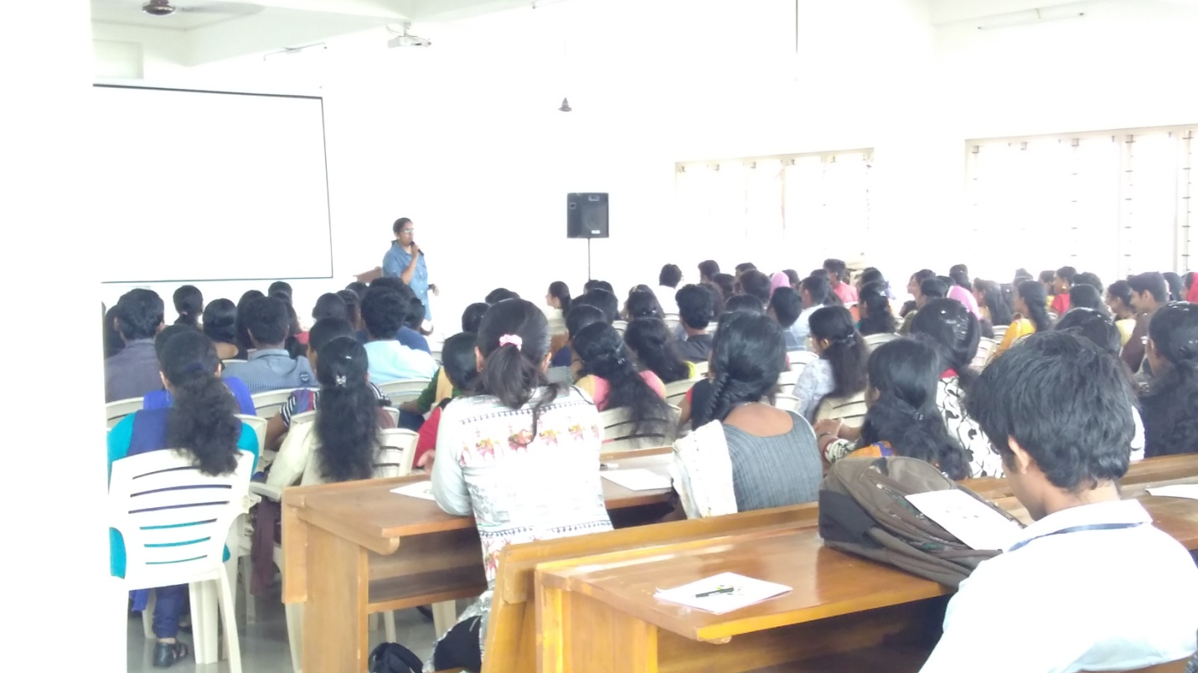
Membership Development Session by Ms.Pooja Manju
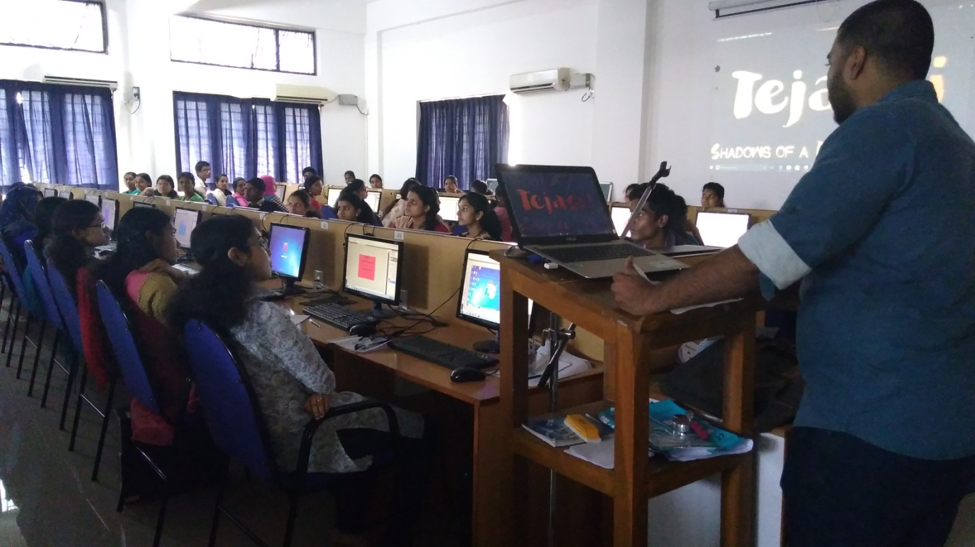
Photoshop workshop by Mr. Nanda Kishore
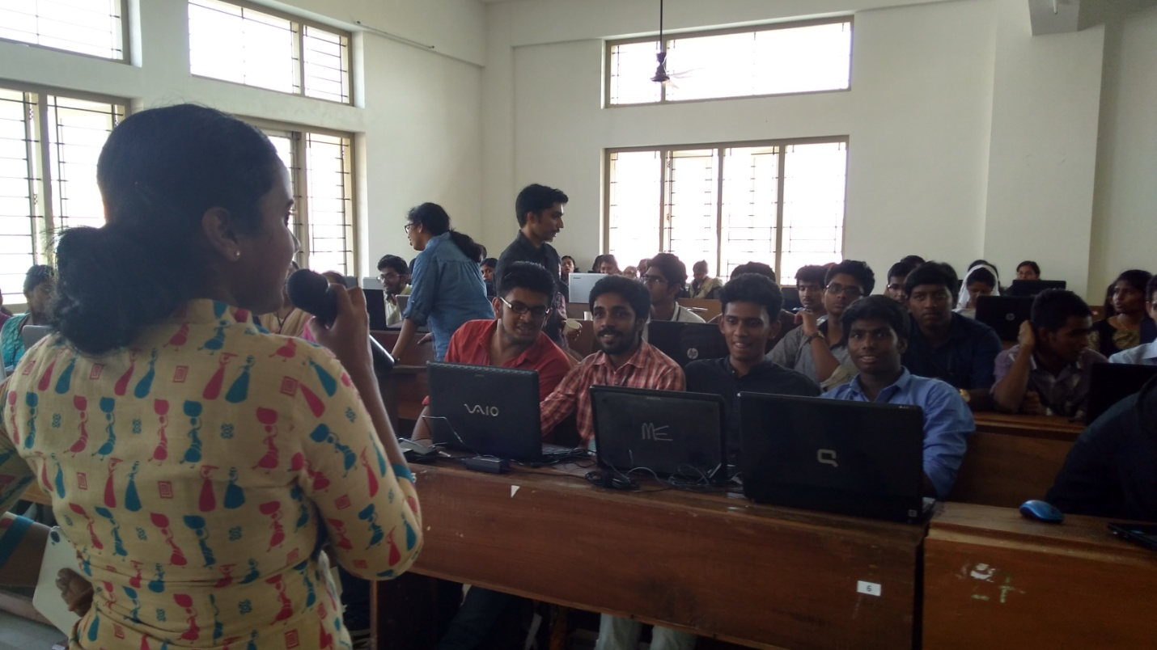
Photoshop workshop by Ms.Megha Ben

